CMR College of Engineering & Technology
(UGC Autonomous)
Kandlakoya, Medchal Road, Hyderabad 501401
Centre for Engineering Education Research (CEER)
Social Innovation in Practice
III Sem A.Y 2023-24
FITNESS SQUARE
ABSTRACT:
In this era of increasing energy costs and decreasing supplies of fossil fuels, emphasis on protecting the environment and creating sustainableforms of power have become vital, high priority projects for modern society. Thus we developed a kit that generating electrical energy by the untapped potential of harnessing kinetic energy produced during gym workouts.Piezoelectric transducer since it is one of the more efficient systems to convert the energy of vibrations. Our project is used for the current era that the produced electricity is like renewable energy. Producing electricity at our comfort space and also this project motivates the people to be Fit and Strong enough.
DESCRIPTION:
The “AQUATHERM”( Water Bottle Heater) is not only convenient, but also eco-friendly. By eliminating the need for disposable water bottles, this product helps reduce waste and promote sustainability.
In addition to being environmentally conscious, the “AQUATHERM”(Water Bottle Heater) is also incredibly convenient. For those who travel frequently or work in an office setting, having hot water readily available can make a world of difference. No more waiting in long lines for a cup of coffee or tea, or struggling to find a kettles to heat up your water. With the Smart Water Bottle Heater, you can have hot water whenever you want it.
CONCLUSION:
Staying hydrated is crucial for maintaining optimal health and performance. In fact, studies show that even mild dehydration can have negative effects on mood, energy levels, and cognitive function.  With the AQUATHERM ( Water Bottle Heater), you can easily stay hydrated all day long. This innovative product allows you to customize the temperature of your water, ensuring that it's always at the perfect level for your needs. When you prefer warm water, the AQUATHERM (Water Bottle Heater) has got you covered. |  | 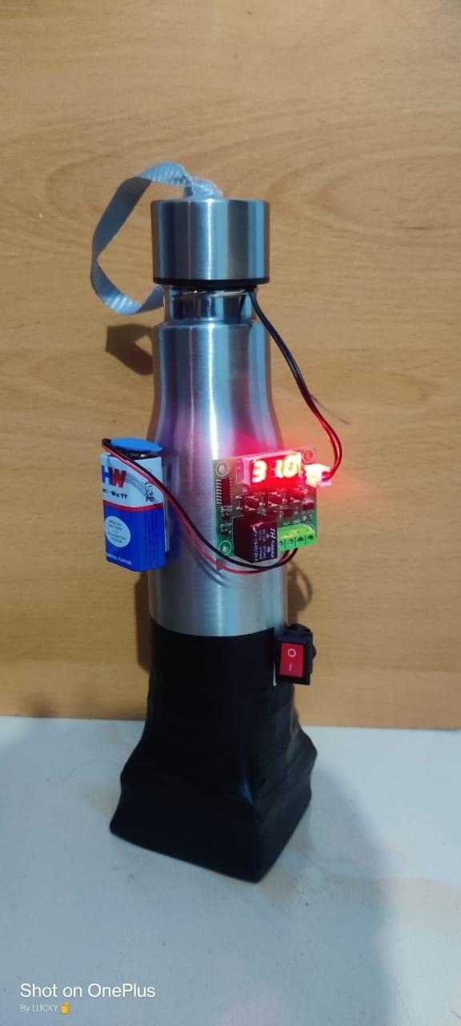
FACULTY STUDENTS
1. Mr. P.Mahesh Babu Asst.Professor CEER/MECH  2. Mr. K.Ravi Kiran Asst.Professor CEER/ECE  3. Mr. B.Venkateshwara Rao Asst.Professor CEER/ECE | AN Tanmay 22H51A6601  C.Nithish 22H51A6612  G.Rishitha 22H51A6625  P.Sreeja 22H51A6650  Prince kumar singh 22H51A6651  T.Aravindh 22H5A6660

